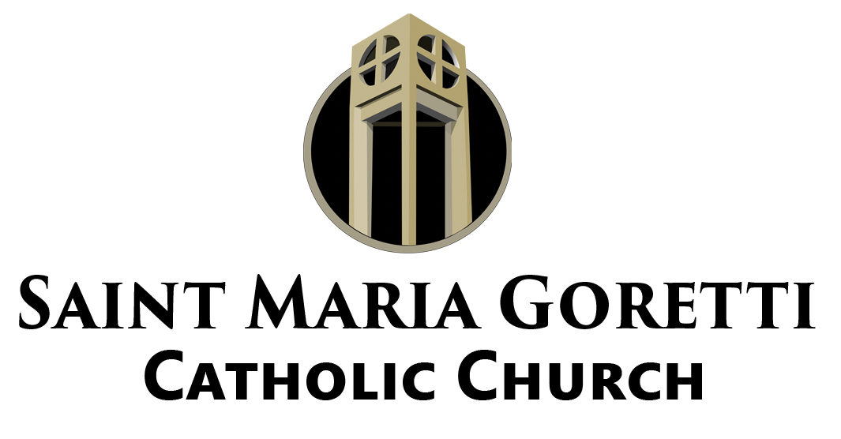

The Goretti Notes

Mass Intentions for the Week
Saturday, October 21st
4:00 PM: Elodie, Darrell, & Bruce Gabriel, Geraldine Small, The Thompson Family, Roy W. Bierria, Jr., Ralph Pierre, Lorraine R. Desbordes, Jason Aubert,
Repose of the soul of Joseph Nguyen, Thelma Chevalier Mouton,
Repose of the soul of Levy J. Bouligny, Jr., Walter Banks, III, and Alton Torregano, Jr.

Sunday, October 22nd
8:30 AM: Parishioners of St. Maria Goretti

10:30 AM: Lucille Grayes, James & Tamerle Young, Shirley Duroncelet,
St. Joseph Altar Group, Ieisha Mikell Johnson, Byron Tregre, Alvin Cousin,
Sharon Evans, Joan Williams, Warren Armstrong, Joseph Reed, Sr.,
Wayne Francis Harris, IV, Enola Thomas, and Callistus Agochukwu

Monday, October 23rd: Sonia Baham
Tuesday, October 24th: Repose of the soul of Melvin Thompson
Wednesday, October 25th: Vicki Mathews
Thursday, October 26th: Warren Pierre
Friday, October 27th: Kim Rochon, Sr.
Saturday, October 28th: In Thanksgiving

EMHC Re-delegation Session
All Extraordinary Ministers of Holy Communion are required to participate in a
re-delegation session so that Archbishop Aymond can issue new delegations for the next five years. The sessions here at St. Maria Goretti will be held on November 4th or November 11th. Both sessions will be from 10 am until 12 noon. Anyone who does not make one of the sessions will have to speak with Fr. Daniel directly. There are no exceptions.

Trunk-or-Treat
We will have our annual Trunk-or-Treat event next Saturday, October 28th at 10:30 am to 12:00 pm. The event will feature games, candy, food, and prizes. We are
thankful to all those parishioners who have signed up to decorate a table, the
Holy Name and Knights of Columbus for providing the food, and those who will judge. Beginning October 1st we will start accepting candy donations for the event. Please be as generous as you can so that we can have a spectacular event once again.

All Saints Day Schedule
For the Solemnity of All Saints, Wednesday, November 1st, we will offer a vigil Mass on Tuesday, October 31st at 6 pm. We will also offer Mass at 8:30 am and 12 noon on November 1st. All parishioners are encouraged to make time to come and pray for the intercession of the Saints as we continue to grow as disciples of the Lord Jesus.

Our Beloved Dead
During the month of November, we will remember the deceased parishioners and loved ones of St. Maria Goretti in a number of ways. During the Masses of
November 4th and 5th we will bless the memorial flags to be placed around campus as a visible sign of those we hold dear and offer to the Lord. We will also have the Book of Dead inserts available at the back of the Church starting on October 28th and 29th so that you may inscribe the names of loved ones and parishioners to be placed at the altar during Mass in November. “May the souls of the faithful departed, through the mercy of God, rest in peace.”

Maintenance Tech Position
We are pleased to welcome Mr. Keith Ealy to St. Maria Goretti as our maintenance technician. Mr. Ealy comes to the position with over eight years of experience serving as Facilities Services Manager at St. Joseph Catholic Community in Arlington, TX. In this position he provided hands-on coordination of maintenance, housekeeping, events, and security of the parish facilities. Mr. Ealy’s first day will be Tuesday,
October 17th. We look forward to the gifts he will share with our parish.

Availability for Prayer
For those parishioners who would like to pray in the Church you are welcome to do so Monday through Friday from 9:00 am to 3:00 pm. If you come to the office the staff will gladly let you into the Church to spend some time with the Lord.
Also, remember that we have Mass daily in the Church for 8:30 am Monday through
Saturday.

Online Giving
Have you signed up for online giving? This will eliminate the need for you to write checks, keep track of your envelopes, or look for cash. You can sign-up on the
homepage of the website.

Journey to Catholicism
Are you or someone you know interested in deepening your faith? Do you know someone who wants to become Catholic that they might commune with God through the Eucharist? Did you complete all your Sacraments of Initiation (Baptism, First Communion, and Confirmation)? If you are interested in taking this journey now or in the future contact the parish office to setup a meeting with Fr. Daniel. This is a personal process that allows anyone interested to come to know Christ better and build a stronger relationship with him.

Social Media
Have you followed us on our social media accounts? The parish Facebook page, St. Maria Goretti Parish, and Instagram account, @smgnola1965, are ways to create community online outside of our Sunday experience.
Be sure to go and like both of those, as well, to stay connected with the parish. The easiest way to find them is by going to the website and clicking on the icons.

